Name:  Class: | ____________________________________  ________________ | Due Date  ______________
 | Year 11 Essential Mathematics  Practical Investigation - 3 2018  Topic – Energy | / 71  Weighting: 12 %
Total Time: | One week (includes 4 lessons)
Weighting: | 12%
Equipment: | Measurement tools for height and weight

Part 1: Energy Use at Home, Nationally and Globally

At Home – When we think of the energy we use at home, we think of the power points, appliances and personal electronics we use on an everyday basis. Most Australian homes contain electrical appliances such as a television, dishwasher, fridge, dryer and computer (in addition to others). Knowing how much these appliances cost is only half the story, we also need to factor in how much they cost to run. To help with this, these appliances have an Energy Rating label on them. Go to the government website www.energyrating.gov.au to find the answers to the following questions:

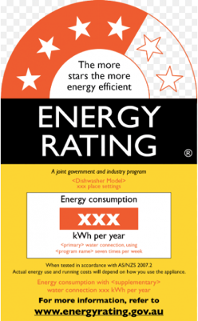
Question 1
- What are the two main features of the energy rating label? [2 marks]

- How is the star rating determined? [2 marks]

- List one other factor that should be considered when buying an appliance? [1 mark]

Question 2
You are ready to buy a new fridge, and have narrowed your choice down to a 3 star model that costs $750 and a 5 star model that costs $1075. Although the 5 star model seems pricey, you’ve decided to compare the long term running costs of the two fridges. Using the Energy Rating Calculator on www.energyrating.gov.au, fill in the following table for a two door fridge 300L fresh food/100L freezer based on Energy Star Rating:

[2 marks]
 | Model 1 – 3 star | Model 2 – 5 star
Star Rating
Energy used each year

Question 3
Your home energy provider, Baldivis Power, charges 34.4 c/kWh used. Using the information from the above table, show all working out to calculate:

- The annual running cost of both models [2 marks]

- The 10-year running cost of both models (assume a constant annual rate of energy consumption).
[2 marks]

- Factoring in the purchase price and the running costs of the two models, which model is cheaper over 10 years, and by how much? (Show all calculations) [2 marks]

Question 4
Many appliances consume electricity even when they are not operating. This is generally referred to as stand-by power consumption. The table shows the average stand-by power consumption for some common household appliances.

Appliance | Stand-by Power (W)
Cordless phone | 3
Television | 10
Computer Monitor | 5
Clock Radio | 4
Laptop | 2

- Calculate the annual energy consumption for the computer monitor in kilowatt-hours if it is left on stand-by for 24 hrs a day for a year. [2 marks]

- If the cost of energy is 26 c/kWh, how much does it cost to keep the computer monitor on stand-by for a year? [1 mark]

Nationally – As Australia continues to grow, there will be a continuing focus on household and national energy consumption, as well as a dialogue surrounding renewable energy sources. Let’s have a quick look at the energy consumed on a national level.

Question 5
The following Home Energy Summary shows how much energy was used by a sample household over a 93 day period:

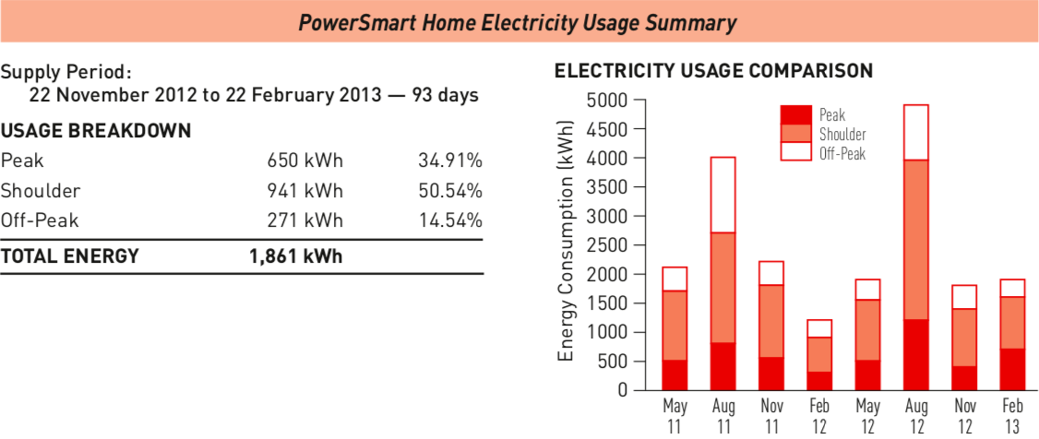

- Assuming energy consumption stays constant throughout the rest of the year, calculate the projected annual energy usage of this home. [2 marks]

- According to the Australian Institute of Family Studies, as of 2011 there were 8,420,000 households in Australia. Using the projected annual energy usage from a), calculate the total household energy output in:

i) kWh [2 marks]

ii) GWh [1 mark]

- The projected number of households in Australia is projected to jump to 12,681,500 in 2036. Calculate the projected total household energy output in 2036 (using the sample household) in:

i) GWh [2 marks]

ii) What % increase in total national energy output is this over 2011’s total national output? [2 marks]

Globally – Australia is consistently among the top 15 world-wide in electricity consumption, but within this top 15, how does it rate comparatively in per capita usage?

Question 6
The following table shows the approximate electricity consumption for 5 of the top 15 users globally, as of 2012. The population of each of these countries is also shown.

Country | Electricity Consumption  (billions kWh) | Population  (millions) | Electricity consumption per capita  (kWh/person, to the nearest 100)
Australia | 225 | 22
Brazil | 456 | 193
Canada | 550 | 34
China | 4690 | 1340
France | 461 | 65

a) Complete the table by calculating the electricity consumption per capita of the five countries [5 marks]

b) Which of these countries has the highest electricity use per person? [1 mark]

c) Which of these countries has the lowest electricity use per person? [1 mark]

d) Where does Australia rank, within these 5 countries, in consumption per person? [1 mark]

e) i] Does the country with the highest consumption per person have the highest population? [1 mark]

ii] Does the country with the lowest consumption per person have the lowest population? [1 mark]

End of Part 1

Part 2: Healthy Lifestyle

Food provides us with the energy we need to function each day. The amount of energy in food is usually measured in kilojoules or in calories if you are in America. We need to eat food to make sure we have enough energy for our daily functions. If we consume more energy than we burn off, our bodies will store the remainder as fat. It is important that we maintain a healthy lifestyle. You have decided that you want to live a healthier lifestyle. Your doctor has recommended that you keep an eye out on what and how much you eat, and how much exercise you do. You are going to set up a healthy eating and exercise regime for yourself.

Question 1
You will need to work out you Base Metabolic Rate (BMR).
- What is Base Metabolic Rate? [2 marks]

- When BMR is calculated the output will be in Calories. Since we use Kilojoules, you will need to work out your BMR, give answer in kilojoules. You will be provided with means to measure your weight and height.
[2 marks]

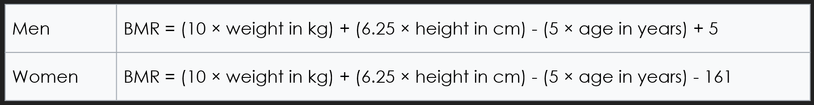

Question 2
You decide to start recording what you eat for breakfast. Here are three days’ worth of entries.

Day 1 |  | Day 2 |  | Day 3
Pancakes | 84 cal | 3 x Bacon | 621 kJ | Bowl of Kellogg’s | 1073 cal
Glass of OJ | 54 cal | 2 x eggs | 1226 kJ | Flat White Coffee | 124 cal
2 x Bacon | 99 cal | Glass of Coconut Water | 148 kJ | 1 x orange | 89 cal
Total: |  | Total: |  | Total:

- Find the total energy value for each day in kilojoule. [3 marks]

- Using your own BMR, what percentage of your recommended daily intake is each breakfast? [3 marks]

- Which breakfast is the healthiest and why? [2 marks]

Question 3
In the appendix you will find recipes designed for females and males. You want to maintain the weight you are now. Pick meals and snacks for a period of four days from the appendix that will keep your weight consistent. Main meals cannot be repeated. [10 marks]

Food Diary |  | Name of Meal | Energy (kJ)
Day 1 | Breakfast
 | Snack
 | Lunch
 | Snack
 | Dinner
Day 2 | Breakfast
 | Snack
 | Lunch
 | Snack
 | Dinner
Day 3 | Breakfast
 | Snack
 | Lunch
 | Snack
 | Dinner
Day 4 | Breakfast
 | Snack
 | Lunch
 | Snack
 | Dinner

Question 4
The final day has been left up to you. You will need to access the internet to find recipes to complete the week. Remember, you are maintaining your weight. [5 marks]

Food Diary |  | Name of Meal | Energy (kJ)
Day 5 | Breakfast
 | Snack
 | Lunch
 | Snack
 | Dinner

Question 5
Calculate your totally energy intake for each day. [3 marks]
- How does these values compare with your daily recommended intake?

- What changes can you make if your totally energy was short or over your recommended intake?

Question 5
It has been recommended to you that you incorporate some exercise in your healthy lifestyle. In order to maintain your weight, you will need to burn the same amount of energy that you consume through eating or drinking. Your body burns energy by breathing and digesting food but exercise increase the amount of energy burnt.

The table below shows approximate amounts of energy used when doing different exercises:
Exercise | Energy burned
Walking | 1100 kJ per hr
Cycling | 2100 kJ per hr
Weight training | 2600 kJ per hr
Jogging | 2700 kJ per hr
Playing sport (footy or netball) | 3000 kJ per hr
Running | 4500 kJ per hr

- You decide that you will start walking to school. It takes you a total of 45 minutes to walk to and from school. How much energy will you have burned? [1 mark]

- If you walked to and from school on Day 1 of your food diary, will you need to eat an extra meal or snack to maintain your daily recommended intake? If so, what kind of snack or meal will you eat? [2 marks]

- Your footy/netball grand final is coming up and your coach decides to schedule an extra training session on Day 3. You train for an hour and a half. What percentage of your daily recommended intake would you have burned off? [3 marks]

End of Investigation

